Childrens Menu
All our kid’s meals are homemade using the freshest and healthiest of ingredients.

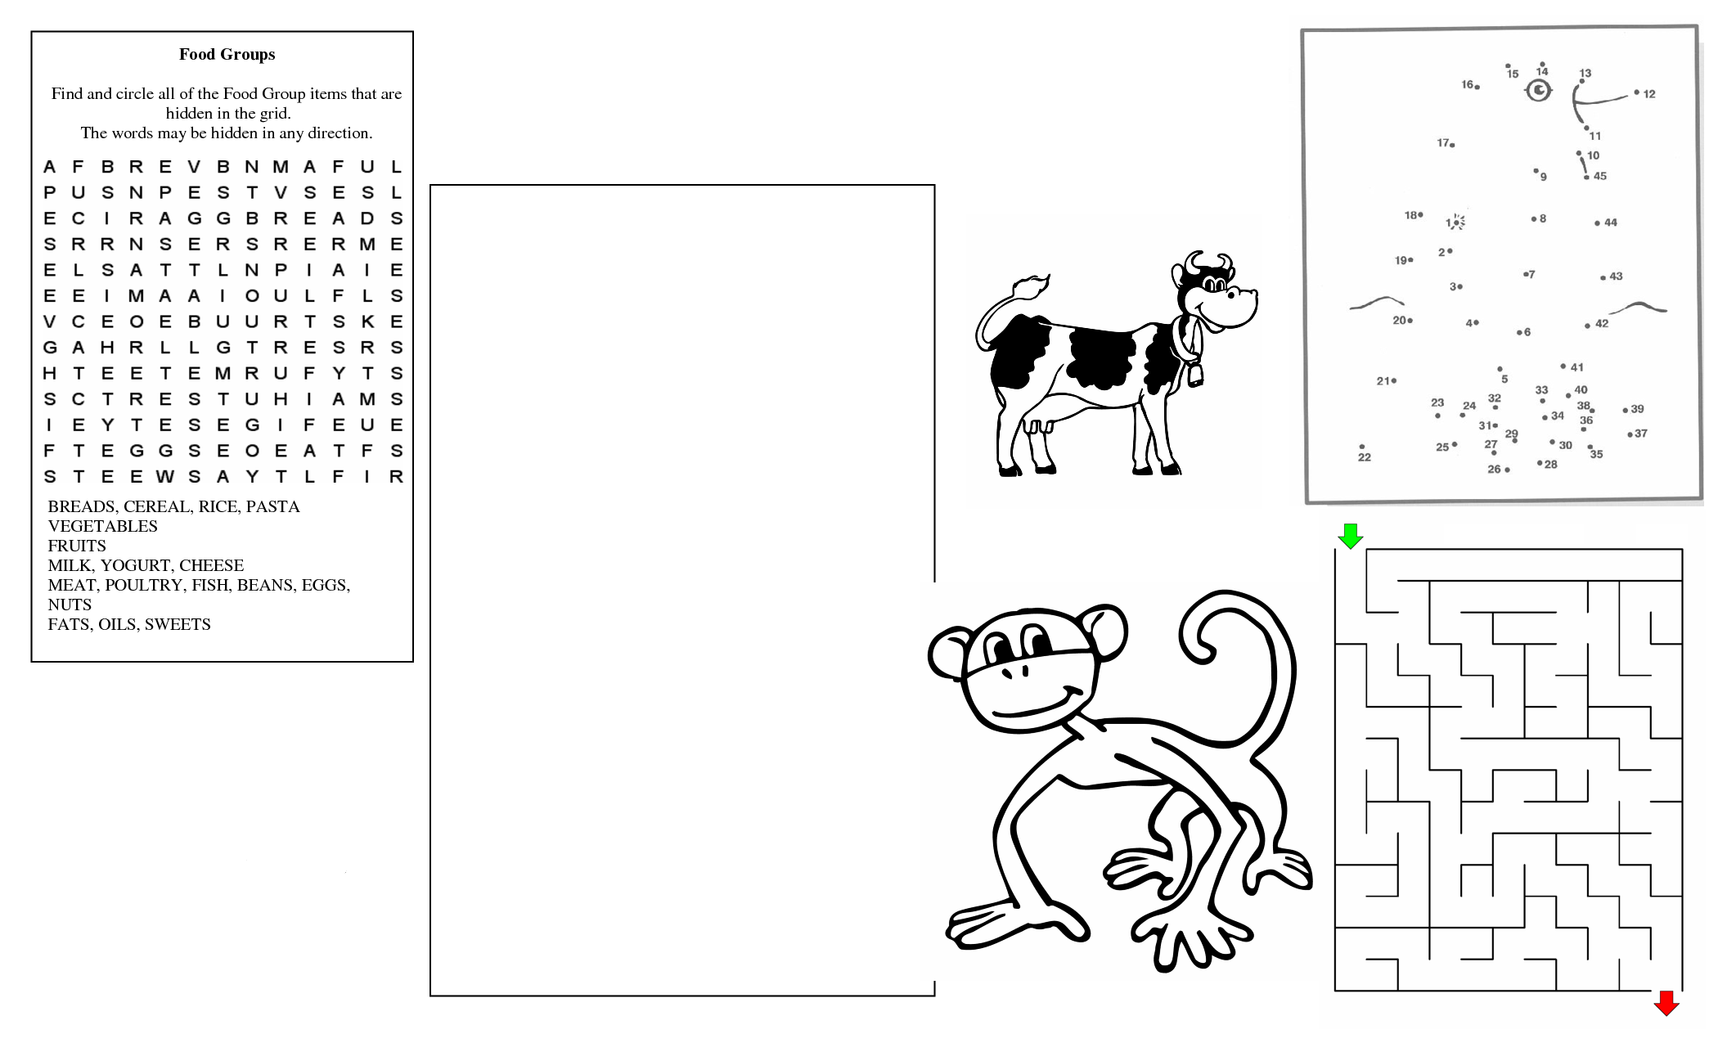
100% breaded Cod Fish Fingers
100% breaded Chicken Breast Strips
3oz Beef Burger topped with Cheese
Cheese & Tomato Ciabatta Pizza
Butchers Pork Sausages
Cheese & Tomato Omelette
Macaroni Cheese
Choose from:
Chips, New Potatoes or Smiley Faces &
Beans, Peas, Salad or Vegetables

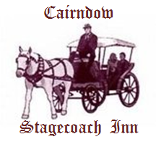
Platter - Ham, Cheese, Crusty Bread
Roll & Fruit

£4.75

